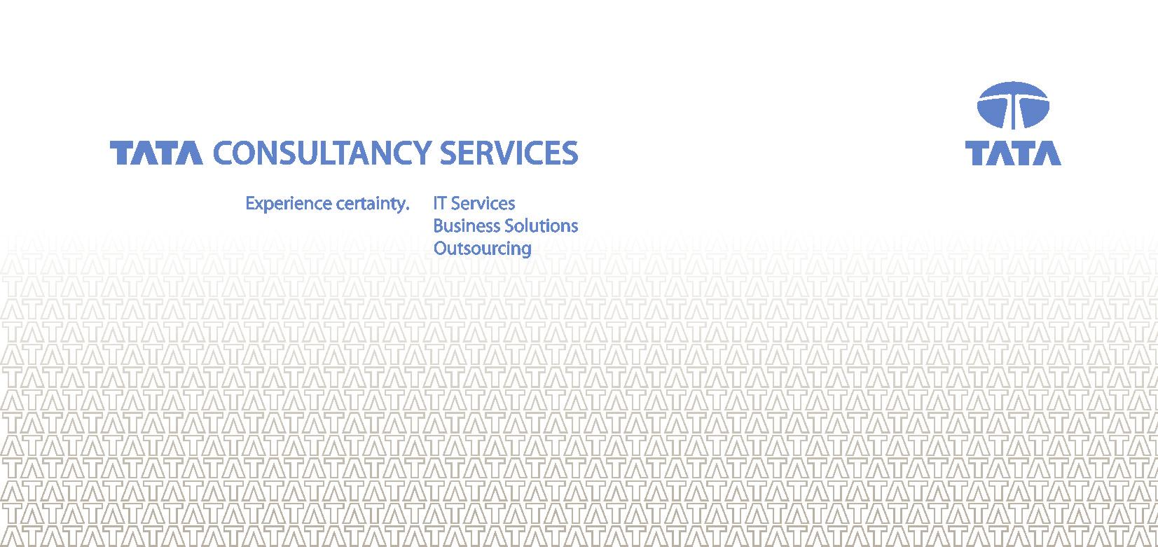

**Document of Understanding**



**<< Application / App Group Name >>**

Authors

| Name | Location | Phone | Email |
| --- | --- | --- | --- |
|  |  |  |  |
|  |  |  |  |
|  |  |  |  |

Revision History

| Date | Author | Description |
| --- | --- | --- |
|  |  |  |
|  |  |  |
|  |  |  |

Table of Contents

A – Functional Overview 6

1. Purpose of the Application 6

2. Business Process flow diagrams 6

3. Sub application details / Key business transaction 6

4. Application User Information 6

5. Application usage pattern & seasonality and special processes 6

6. Support and Coverage requirements 6

7. Overview of Functionality and brief descriptions of key process 6

8. Online – Screen Inventory (for custom built) 6

9. Special data handling or security requirements (where applicable) 7

10. Computations 7

11. Dependencies 7

12. History Related With the application 7

13. Languages supported (If Multilingual) 7

B – Technical Overview 7

14. Technology Stack 7

15. License Requirements 8

16. Technology Variances 8

17. System architecture diagram 8

18. Database Architecture 8

a. Physical data model & Logical data model 8

b. List the key tables and their mapping to the transactions. 9

19. Backup, Recovery & Archival 9

20. Infrastructure Architecture Diagram for all Environments 9

21. Number of Instances 9

22. Performance and Availability 10

23. Scheduled Upgrades 10

24. Setup Procedures 10

25. Interfaces 10

26. Critical Jobs / Integration needs / Schedules 10

27. Technical data sheets 10

28. Detail the Do’s & Don’t’s and specific test scenarios 10

C – Operational Overview 12

29. Ticketing System 12

a. Tools 12

b. Reports 12

30. Quantitative Assessment of Ticket data. 12

a. Analyze Application Incident data. 12

b. Trend Analysis 12

31. Operating Procedures 12

a. Incident Management (all types) until Ticket closure. 12

b. Incident Reporting & Recording Mechanism. 12

c. Planned Activity Resolution Process. 12

d. Unplanned activity Resolution Process. 12

e. Disaster Recovery process 12

f. Change Management Process. 12

g. Deployment Process 13

h. Log Locations / Enabling / De bugging Process 13

i. Release management frequency & process 13

j. Installation Process. 13

k. Rollback Management. 13

l. Third party Support including Helpdesk 13

m. After hours support procedure 13

32. Configuration Management. 13

a. Configuration Management Process. 13

b. Configuration Mgmt (People, Hardware, Software,other assets). 13

33. Communication Process. 13

a. Communication within the Team and Client. 13

b. Escalation Process and Touch Points. 13

c. Customer Communication Framework for Jobs, Monitoring. 13

34. Verification and Validation process. 14

a. Application Functionality Verification. 14

b. Performance Testing. 14

c. System Integration Testing Process. 14

35. Process templates 14

D – Known Issues, Bugs, Knowledgebase, Dependencies 14

# A – Functional Overview

## Purpose of the Application

*[Mention the Business case for the existence of this application]*

## Business Process flow diagrams

<<Mandatory for Critical Business Process Flow, optional for rest>>

*What business Processes are supported by this Application? What are the key application sub modules ? Prepare process flow diagrams for the key businesses processes . Ensure the detailing is adequate to understand the overall process flow.*

## Sub application details / Key business transaction

[Associate the key business process listed above with the *key transactions. If the application is rule based ensure detailing the business rules.]*

## Application User Information

|  |  |  |  |  |
| --- | --- | --- | --- | --- |
| Department/User Group | Key area/functionality of the application used | Number of Users | | IT Site Contact Person (if needed) |
| Total | Concurrent* |
|  |  |  |  |  |
|  |  |  |  |  |
|  |  |  |  |  |

## Application usage pattern & seasonality and special processes

*[Mention the Frequency of the Usage of this System,. List any processes which are seasonal. Establish if there exist any peaks or troughs in the support requirements. Establish a list of month end / quarter / annual processes or any adhoc processes which require special focus . Document and detail the frequency , activities and steps related with these processes ]*

## Support and Coverage requirements

*[ Establish the application support coverage requirements, peak hours, any special alert mechanism that exists, escalation process and prioritization requirements, if any ]*

## Overview of Functionality and brief descriptions of key process

## Online – Screen Inventory (for custom built)

*[inventory of screens and brief functional description ]*

## Special data handling or security requirements (where applicable)

*[Mention data Security Related requirements?/ Compliance requirements ]*

## Computations

<<Mandatory for Critical business rules, optional for rest>>

*[Any assumptions related to Application. Such as rounding , handling multiple currencies , data formats etc ]*

## Dependencies

[*Any third party dependencies for the application, Eg ; Hosted applications , data availability .]*

## History Related With the application

*[Document in context of the application the following parameters:*

* *Age of the application since inception*
* *Past Technology Upgrades in relation with the application*
* *Major enhancement made to the application in recent past*
* *The peak support periods & Peak enhancement period for the application and the reason for the peak]*

## Languages supported (If Multilingual)

*[ List the languages the application supports and any multi lingual support requirements for this application.]*

# B – Technical Overview

## Technology Stack

## 

*[Detail:*

* *Application type ( Web based , Client server , Procedure / Package Only etc )*
* *Application Stage ( Establish if the application is released to Production or still under development / testing )*
* *Detail the Hardware ( if required )*
* *Detail the Operating system*
* *Detail the Software / Language*
* *Detail the tools and any Integration technologies used*
* *Detail all major and minor technologies / frameworks the application is built with.*
* *the latest versions.*
* *Detail the data store*
* *Detail the version control tool*
* *In case of products establish the market name of the product, version & vendor details.*
* *Establish if vendor AMC for third party product / support is required ; and is available or not through Customer’s*
* *Cover Database, Administration / Security , Front-end GUI , Application server , Language , API’s , Encryption , Monitoring tools , Development tools , Reporting tools, Integration tools, Workflow , Rules engine etc ]*

## License Requirements

*[Mention the Software Licences /Requirements/Availability (if pertinent for support requirement / offshore access]*

## Technology Variances

*[Mention any variance in the Technology Stack used by Application as against the known Customer’s standards, state any proprietary language]*

## System architecture diagram

*[Provide Current technical blue print (where applicable) , system interactions, architecture layers and software layers]*

## Database Architecture

## Physical data model & Logical data model

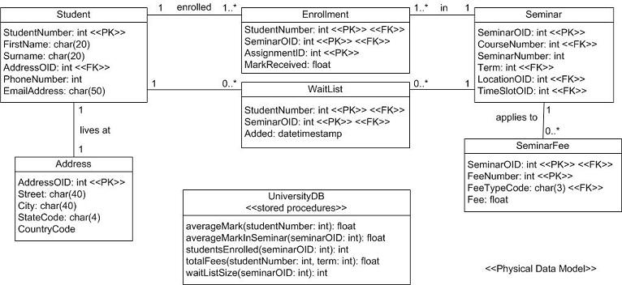

*[Example power designer models]*

## List the key tables and their mapping to the transactions.

## Backup, Recovery & Archival

*Describe how the data in the system will be backed up and restored (near*

*term), and how will it be retained/archived (long term).*

## Infrastructure Architecture Diagram for all Environments

Provide an overview diagram detailing the server architecture for this system. Include elements such as the server layout, network setup, storage, LDAP, and how failover and scalability will be achieved. Also, if the Test/QA environments will not exactly match Production then show that setup as well. If this is an existing infrastructure, be sure to highlight any changes or additions in this diagram.

## Number of Instances

*[ List the number of instances for the application. Clearly state whether the instance is a development, testing , staging or production instance . Establish if the instance is synchronized with production. Establish specific accessibility parameters. Does production have a single instance (centralized) or multiple instances ( distributed ) by geography ]*

|  |  |  |  |  |  |
| --- | --- | --- | --- | --- | --- |
| Instance  No | Instance type  ( Eg : Production , Development , Testing ) | Instance Location  [ If hosted outside Customer’s Network ] | Synchronization with Production Instance , State Yes / No | Accessibility  Details ( URL , IP Address etc ) | Remarks / Centralized / Decentralized |
|  |  |  |  |  |  |
|  |  |  |  |  |  |
|  |  |  |  |  |  |
|  |  |  |  |  |  |
|  |  |  |  |  |  |
|  |  |  |  |  |  |
|  |  |  |  |  |  |
|  |  |  |  |  |  |

Detail the ALL access URL and links for different components such as

* Local databases
* Version control tools
* Application URL
* Reports etc

## Performance and Availability

<< Document any special performance characteristics / availability requirements of the application>>

## Scheduled Upgrades

*[Mention about the any Technical Upgradations planned with timelines.]*

## Setup Procedures

*[ Detail the setup procedures for the applications in its target environment ]*

## Interfaces

*[Identify the DATA IN interfaces and the DATA OUT interfaces and approximate classification of dependencies. Refer any documents where available from Customer’s.*

## Critical Jobs / Integration needs / Schedules

*[Identify critical jobs , schedules , specific integration needs , queues and related constraints. Establish all special processes , month end , day end , week end etc ]*

*Critical Job Information – (if application has critical jobs that will be monitored list details in this table)*

|  |  |  |  |  |  |
| --- | --- | --- | --- | --- | --- |
| *Critical Job* | *Server or Site* | *Schedule Name* | *Scheduled Completion (Due out time))* | *Impacts if not completed on time* | *Notifications Needed if late* |
|  |  |  |  |  |  |
|  |  |  |  |  |  |
|  |  |  |  |  |  |
|  |  |  |  |  |  |

## Technical data sheets

*[ Collect standards , batch jobs , sequence diagrams as required under the respective technologies ]*

## Detail the Do’s & Don’t’s and specific test scenarios

*As part of knowledge transition establish the available test case scenarios , do’s and don’ts for the given application.*

# C – Operational Overview

***[ If processes are common across all applications , these could Common processes could be segregated out in a separate document]***

## Ticketing System

## Tools

*[ Mention about the tool used by the users to log the issues/Tickets , links , authentication ,authorization etc)*

## Reports

*[What reports are generated from this tool , how is it reported to the customer ,, format etc]*

## Quantitative Assessment of Ticket data.

## Analyze Application Incident data.

*[Percentage of ticket data in planned / unplanned, % by criticality,% by data issues , production support issues , breakfix related etc ]*

## Trend Analysis

*[Gather the Ticket data for the application for last 3-4 months. Get the Root Cause analysis document from the present incumbent.]*

## Operating Procedures

## Incident Management (all types) until Ticket closure.

## Incident Reporting & Recording Mechanism.

*[How the incidents are reported , where they are logged , how it is being accessed etc)]*

## Planned Activity Resolution Process.

## Unplanned activity Resolution Process.

## Disaster Recovery process

## Change Management Process.

#### Change Control and Change Approval Board Information.

*[List the steps that should be taken to initiate the change control , to get the approval etc)Documents and templates to be used].*

#### Communication Process

*[Who needs to be contacted for the CR’s and how. List the tools, contacts etc.]*

## Deployment Process

## Log Locations / Enabling / De bugging Process

## Release management frequency & process

## Installation Process.

*[How the application is being Installed in Development , staging and Production environment.]*

## Rollback Management.

*[How is the Application rollback done in case of any issues with deployment.]*

## Third party Support including Helpdesk

*[Document the details of third party involvement for providing support]*

## After hours support procedure

*[Document the afterhours support procedure]*

## Configuration Management.

## Configuration Management Process.

*[Mention the overall Process of doing changes to the source code ]*

## Configuration Mgmt (People, Hardware, Software,other assets).

*[List down the key people and their contacts , tool used for CM , software required to access the tool and any special; hardware/software Requirements*.]

## Communication Process.

## Communication within the Team and Client.

*[How the status reports are shared , template . Frequency of client meeting ,Team meeting , MOM’s etc .]*

## Escalation Process and Touch Points.

*[Depict the Escalation Process with details like (Name , Contact information)]*

## Customer Communication Framework for Jobs, Monitoring.

*[How the Jobs failure/success is being reported to client. Who needs to be contacted in case of major failure etc].*

## Verification and Validation process.

## Application Functionality Verification.

*[Get the UAT test cases etc and Process to Verify application Functionality.]*

## Performance Testing.

*[How the Performance Testing being Done. Is it the TCS scope or Customer’s scope. What tools are used etc and what are the metrics.]*

## System Integration Testing Process.

*[Understand the Defect logging Process , tools etc]*

## Process templates

Obtain templates and relevant formats for Unplanned / Planned activities

# D – Known Issues, Bugs, Knowledgebase, Dependencies

*<<Document the availability and details as applicable>>*